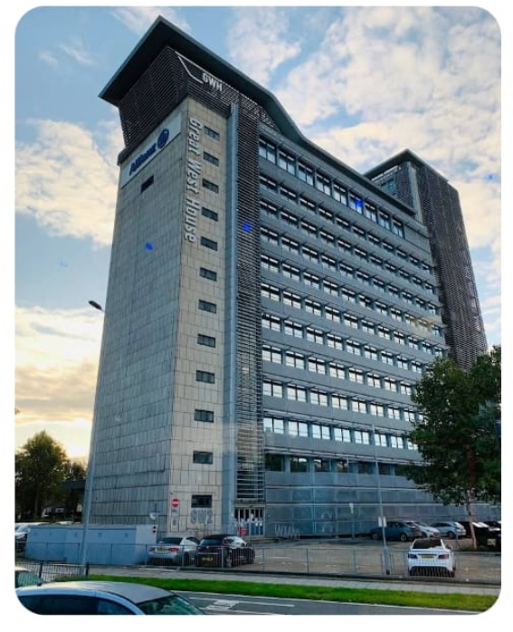

Client: Confidential
Project Start Date: February 2025
Project End Date: January 2026
Project Value: 1.2million
Project Scope: Soft Strip & Controlled demolition – Central London Commercial Building Great West House.
Project Description
Reciprocus was appointed to undertake the soft strip & controlled demolition for two high rise commercial buildings located in central London.
The project involved a 10 storey and a 17-storey building, covering a combined 100,000 m2 over two blocks. Both structures required extensive internal strip-out and selective demolition – all carried out in a live urban environment with strict safety and environmental controls.
Scope of Works
- Full soft strip of both high-rise buildings, removing all non-structural elements.
- Controlled demolition of both structures in stages, ensuring safety and minimal disruption.
- Floor scabbling works carried out across 27 levels, preparing concrete surfaces for subsequent redevelopment and ensuring removal of adhesive residue and contaminates.
- Removal and recovery of 100,00m2 of raised computer flooring, carefully dismantled and supplied to a supply chain partner for reuse.
- Implementation of circular economy practices to maximise reuse, recycling and landfill diversion.
Approach and Methodology
Given the project’s complexity and size, detailed planning and sequencing were essential.
Reciprocus implemented a phased work strategy to ensure safety, efficiency and environmental compliance:
- Conduct comprehensive pre demolition and asbestos surveys to map out ACM’s and high-risk area.
- Methodical soft strip operations to separate recyclable and reusable materials.
- Surface preparation and floor scabbling undertaken with dust suppression and waste collection measures to maintain air quality.
- Demolition sequencing managed to minimise vibration and disturbance in the busy central London setting.
- All materials were segregated, catalogued and tracked to demonstrate compliance with environmental and circular economy principles.
These actions delivered a major reduction in landfill waste and contributed to carbon savings for both the client and Reciprocus sustainability targets.
Conclusion
This project demonstrates Reciprocus’ ability to deliver large scale demolition projects in demanding central London environments – combining technical precisions, sustainability, and safety excellence. Through meticulous planning and innovative reuse strategies, the team not only met but exceeded environmental targets, reinforcing Reciprocus’ position as a leader in responsible demolition and circular economy practice within the UK construction sector.
